|  |
| --- |
| MODIFYING YOUR FIELDS |

So you’ve begun to browse through your modules and tried creating new entries but find the fields not suiting your expectations? We will go back to the Cobalt code generator and make modifications to those fields so they are rendered properly.

**CONFIGURING DATABASE FIELDS**

Back in the Cobalt Control Center, navigate to the “Fields” option, where you will be taken to the list of fields that your table import process earlier has acquired from the database.

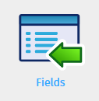

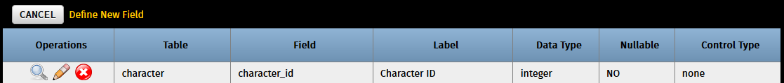

You might have noticed that in creating a new character in our system, the fields were all rendered as textboxes. Changing their field types and customizing them further can be done here. For starters, let’s make modifications to the date_created field so that it displays a date selection field instead of a regular textbox.

Click the pencil icon beside the date_created field to configure it.

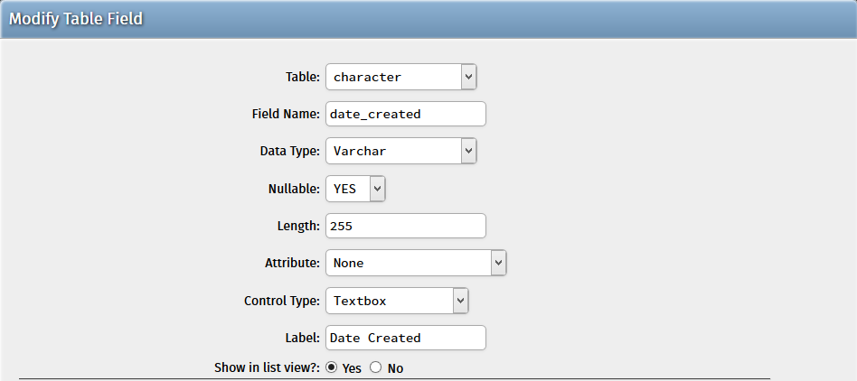

Change the control type to “Date Controls” and hit “Submit” at the bottom of the form.

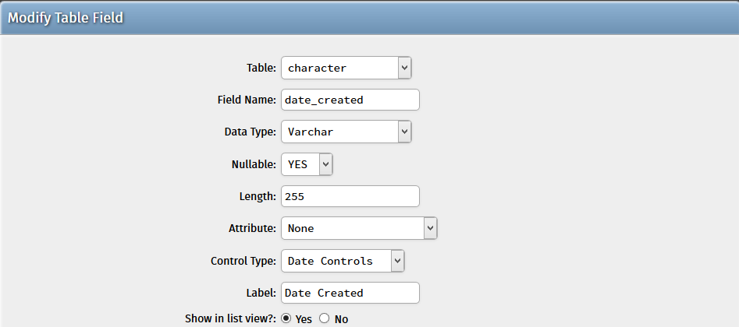

To verify that the field has indeed changed, we need to regenerate the project. Navigate back to the Control Center and select “Generate Project” once more. This time, we need not generate everything all over again – ***only the table whose fields we changed***. Also, since we have already generated the CRUD modules, we no longer need to generate them a second time. The same goes for the standard application components, core files, and system administration components.

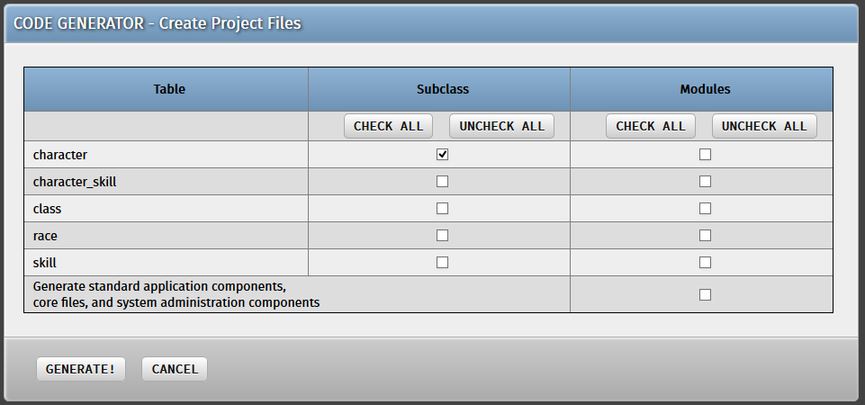

Hit “Generate!” and navigate to the generated files in the /cobalt/Generator/Projects directory.

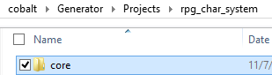

Inside there should be a /core folder. Copy that folder and paste it on your existing project folder, making sure that any existing files in the project folder are overwritten by your newly-generated files.

Navigate back to the “Character” module and hit “Add new record”. In the form you will find that the “Date Created” field is now a date field!



There are several options for configuring fields in Cobalt, enabling you to transform database fields into more context-appropriate ones such as textareas, dropdown fields, radio buttons, or file-upload fields. From the field configuration form you can also tweak attributes of the field such as its maximum length and label on the form for rendering purposes.

**TRY IT YOURSELF!**

Several other fields need modification on our Character Management System. See if you can change this field from its default textbox configuration to a more appropriate control type:

* character > character_portrait: file upload